**Nama: Suci Asri Novariane**

**NIM: 12030123120011**

**Mata Kuliah/Kelas: Analisis Desain dan Sistem/ C**

Link Chatling:

<https://app.chatling.ai/projects/5595977686/chatbots/6486138686/builder>

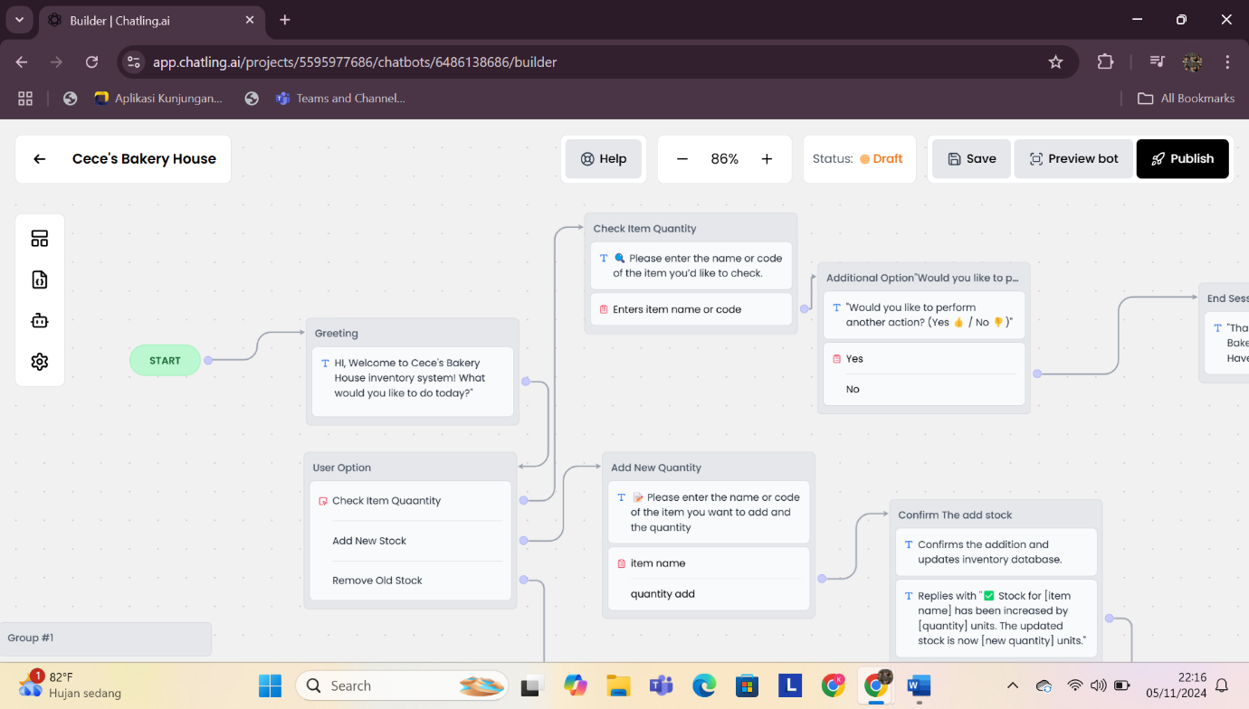

Preview Percakapan Hasil Chatbot

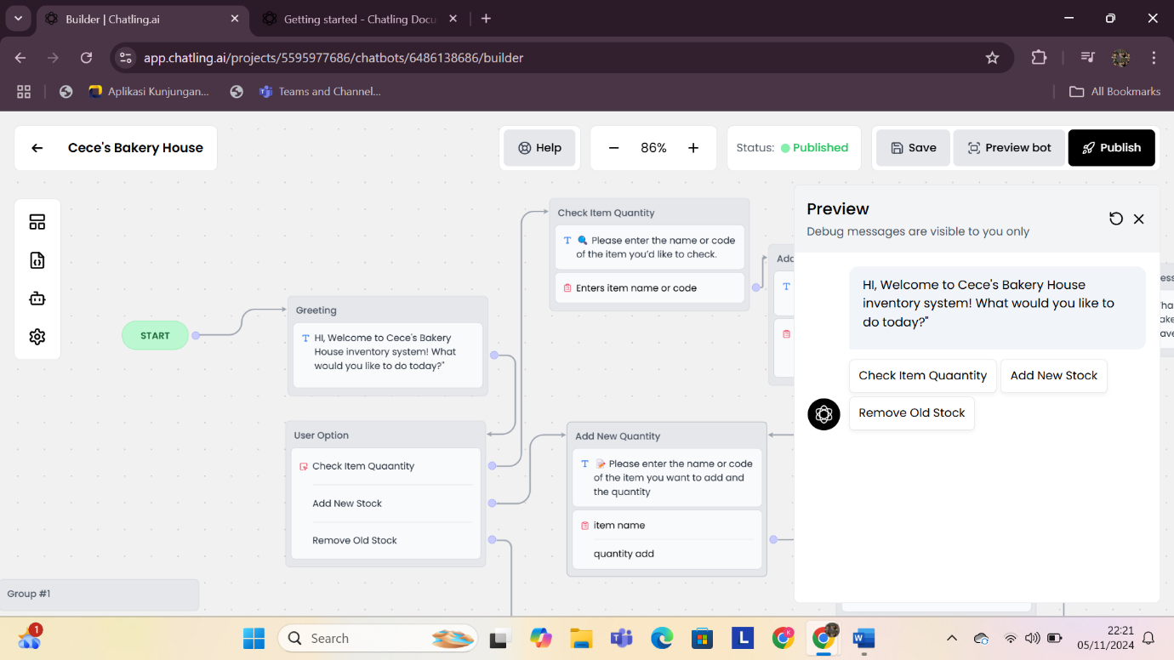

Copytext Perintah Chatgpt

**Cece's Bakery House Inventory System Chatbot Workflow**

1. **Start**
   * **Chatbot**: "👋 Welcome to Cece's Bakery House inventory system! What would you like to do today?"
   * **User Options**:
     + **A**. 📦 Check item quantity
     + **B**. ➕ Add new stock
     + **C**. ➖ Remove sold stock
2. **Check Item Quantity 📦**
   * **If the user selects option A**:
     + **Chatbot**: "🔍 Please enter the name or code of the item you’d like to check."
     + **User**: Inputs item name or code.
     + **Chatbot**: "📊 The current stock for **[item name]** is **[quantity]** units."
     + **Chatbot** (Additional Option): "Would you like to perform another action? (Yes 👍 / No 👎)"
       - If **Yes**, return to the main menu.
       - If **No**, end the session.
3. **Add New Stock ➕**
   * **If the user selects option B**:
     + **Chatbot**: "📝 Please enter the name or code of the item you want to add and the quantity."
     + **User**: Inputs item name and quantity to add.
     + **Chatbot**: "✅ Stock for **[item name]** has been increased by **[quantity]** units. The updated stock is now **[new quantity]** units."
     + **Chatbot**: "Would you like to perform another action? (Yes 👍 / No 👎)"
       - If **Yes**, return to the main menu.
       - If **No**, end the session.
4. **Remove Sold Stock ➖**
   * **If the user selects option C**:
     + **Chatbot**: "🛒 Please enter the name or code of the sold item and the quantity sold."
     + **User**: Inputs item name and quantity sold.
     + **Chatbot**: "✅ Stock for **[item name]** has been decreased by **[quantity]** units. The updated stock is now **[new quantity]** units."
     + **Chatbot**: "Would you like to perform another action? (Yes 👍 / No 👎)"
       - If **Yes**, return to the main menu.
       - If **No**, end the session.
5. **Low Stock Notification ⚠️**
   * When stock reaches a low threshold:
     + **Chatbot**: "⚠️ Low stock alert! The stock for **[item name]** is now at **[quantity]** units. Please consider restocking soon."
     + **Chatbot** (Option): "Would you like to add this item to the reorder list? (Yes ✅ / No ❌)"
       - If **Yes**, go to the **Add New Stock** flow.
       - If **No**, return to the main menu.
6. **End Session 🚪**
   * **Chatbot**: "Thank you for using Cece's Bakery House inventory system! Have a great day! 🍞🍰🍪"